1-Hardware-Based Server

🖥️ What is a Hardware-Based Server?
# Source: Chatgpt (GPT-5-Mini) at [1/16/2026]
A hardware-based server is a physical machine specifically built to run server tasks — such as hosting websites, databases, files, or applications — with dedicated hardware components designed for performance, stability, and scalability.
📌 In simple terms: it's a real server computer, not a virtual or software-simulated one.

🧩 Hardware vs Software-Based Server
# Source: Chatgpt (GPT-5-Mini) at [1/16/2026]
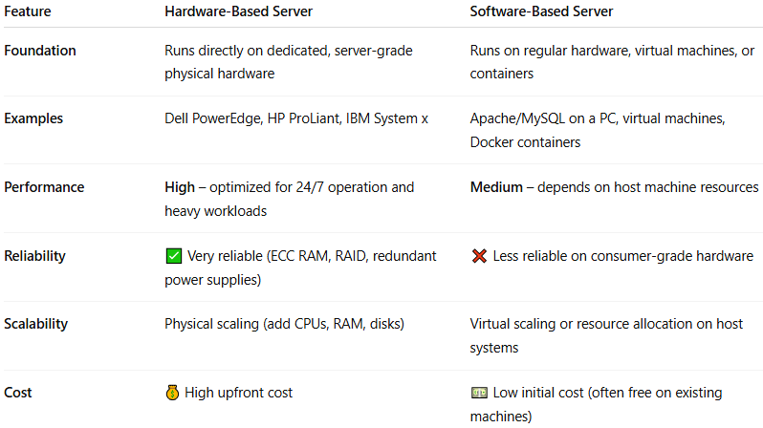
Feature | Hardware-Based Server | Software-Based Server
Foundation | Runs directly on server-grade physical hardware | Runs on regular hardware or virtual machines
Examples | Dell PowerEdge, HP ProLiant, IBM System x | Apache/MySQL on PC, virtual machines, containers
Performance | High – optimized for 24/7, large workloads | Medium – depends on host machine resources
Reliability | ✅ Very reliable (ECC RAM, RAID, redundant power) | ❌ Less reliable on consumer-grade hardware
Scalability | Hardware-based scaling (add disks, CPUs, RAM) | Scales virtually or by host resource allocation
Cost | 💰 Expensive upfront | 💵 Low initial cost (or even free on existing machines)

🧠 Common Use Cases
# Source: Chatgpt (GPT-5-Mini) at [1/16/2026]
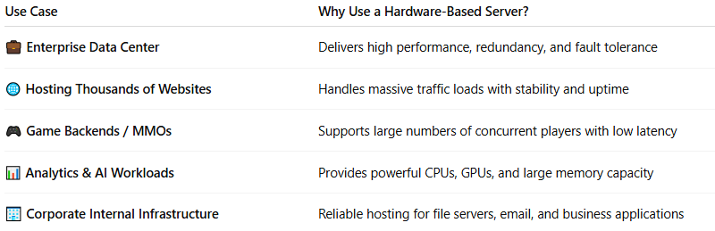
Use Case | Why Use Hardware-Based Server?
💼 Enterprise Data Center | High performance + fault tolerance
🌐 Hosting thousands of websites | Handles high traffic with stability
🎮 Game backends or MMOs | Manages many concurrent players
📊 Analytics/AI workloads | Needs high CPU, GPU, and memory
🏢 Corporate internal infrastructure | File, email, and application hosting

🧰 Typical Components of a Hardware Server
# Source: Chatgpt (GPT-5-Mini) at [1/16/2026]
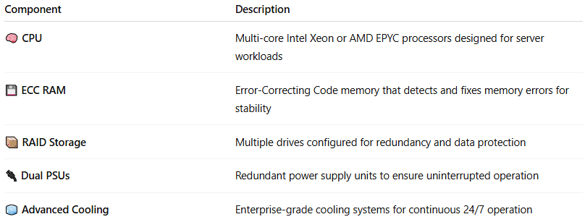
Component | Description
🧠 CPU | Often multi-core Xeon or EPYC processors
💾 ECC RAM | Error-Correcting Memory for stability
📦 RAID Storage | Redundant drives for data safety
🔌 Dual PSUs | Redundant power supply units
🧊 Advanced Cooling | Keeps system running 24/7 without overheating

🏢 Examples of Hardware-Based Servers
# Source: Chatgpt (GPT-5-Mini) at [1/16/2026]
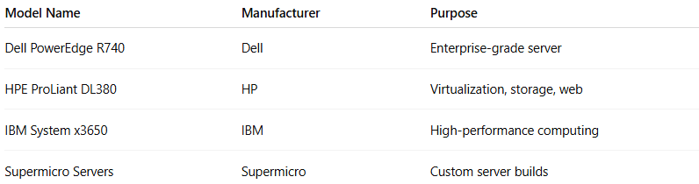
Model Name | Manufacturer | Purpose
Dell PowerEdge R740 | Dell | Enterprise-grade server
HPE ProLiant DL380 | HP | Virtualization, storage, web
IBM System x3650 | IBM | High-performance computing
Supermicro Servers | Supermicro | Custom server builds

🖼️ Visual Overview
# Source: Chatgpt (GPT-5-Mini) at [1/16/2026]
[ Rack Server Hardware ]
├─ CPU: Intel Xeon Gold
├─ RAM: 128GB ECC
├─ Storage: 4x SSD (RAID 10)
└─ OS: Ubuntu Server / Windows Server
↑
Runs apps: Apache, MySQL, File Share, VMs, etc.

✅ Summary
# Source: Chatgpt (GPT-5-Mini) at [1/16/2026]
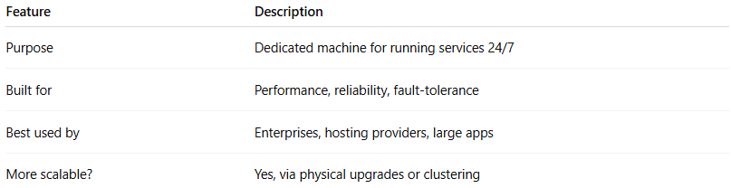
Feature | Description
Purpose | Dedicated machine for running services 24/7
Built for | Performance, reliability, fault-tolerance
Best used by | Enterprises, hosting providers, large apps
More scalable? | Yes, via physical upgrades or clustering

2-Software-Based Server

💻 What is a Software-Based Server?
# Source: Chatgpt (GPT-5-Mini) at [1/16/2026]
A software-based server is a server that relies on software—not specialized hardware—to provide its services. It runs on general-purpose computers (like regular PCs or virtual machines) and uses server software to perform tasks like file sharing, web hosting, database management, etc.
📌 In simple terms: it's a regular computer running server software, not a physical server appliance.

🧠 Key Concept
# Source: Chatgpt (GPT-5-Mini) at [1/16/2026]
Unlike hardware-based servers (e.g., network appliances or blade servers), a software-based server:
- Uses off-the-shelf hardware (can even be a laptop or virtual machine)
- Provides services because of the software running on it, not the hardware itself

🔍 Examples of Software-Based Servers
# Source: Chatgpt (GPT-5-Mini) at [1/16/2026]
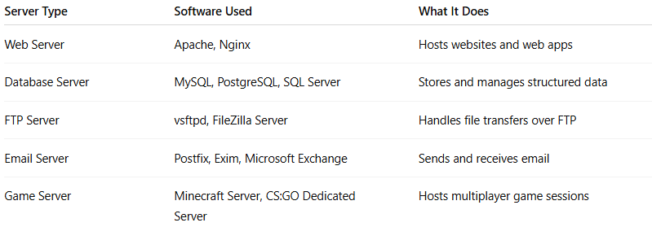
Server Type | Software Used | What It Does
Web Server | Apache, Nginx | Hosts websites and web apps
Database Server | MySQL, PostgreSQL, SQL Server | Stores and manages structured data
FTP Server | vsftpd, FileZilla Server | Handles file transfers over FTP
Email Server | Postfix, Exim, Microsoft Exchange | Sends and receives email
Game Server | Minecraft Server, CS:GO Dedicated Server | Hosts multiplayer game sessions

🧩 Hardware vs Software-Based Servers
# Source: Chatgpt (GPT-5-Mini) at [1/16/2026]
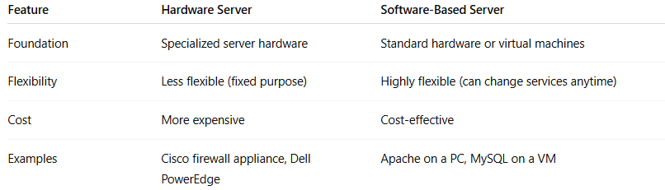
Feature | Hardware Server | Software-Based Server
Foundation | Specialized server hardware | Standard hardware or virtual machines
Flexibility | Less flexible (fixed purpose) | Highly flexible (can change services anytime)
Cost | More expensive | Cost-effective
Examples | Cisco firewall appliance, Dell PowerEdge | Apache on a PC, MySQL on a VM

💡 Use Cases
# Source: Chatgpt (GPT-5-Mini) at [1/16/2026]
- Small businesses: Use software servers on PCs or VPSs instead of buying hardware
- Development/testing: Spin up temporary servers on laptops or VMs
- Cloud computing: Most cloud servers are software-based virtual machines

Visual: How Software-Based Servers Work in a Network
# Source: Chatgpt (GPT-5-Mini) at [1/16/2026]
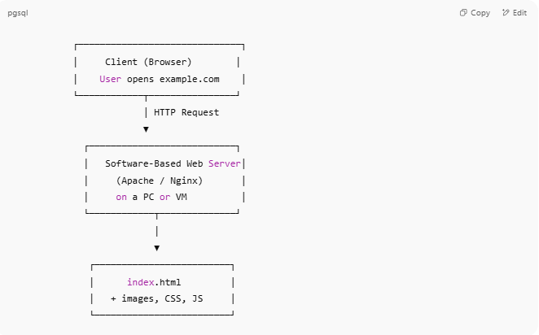
┌──────────────────────────────┐
│ Client (Browser) │
│ User opens example.com │
└────────────┬────────────────┘
│ HTTP Request
▼
┌───────────────────────────┐
│ Software-Based Web Server│
│ (Apache / Nginx) │
│ on a PC or VM │
└────────────┬──────────────┘
│
▼
┌─────────────────────────┐
│ index.html │
│ + images, CSS, JS │
└─────────────────────────┘

Turn Your PC into a Web Server Using Apache (Windows Example)

✅ Step-by-Step (with XAMPP — beginner friendly):

🧰 What you need:
# Source: Chatgpt (GPT-5-Mini) at [1/16/2026]
- XAMPP (includes Apache, PHP, MySQL)

🔧 Installation:
# Source: Chatgpt (GPT-5-Mini) at [1/16/2026]
- Download and install XAMPP from the official site.
- Open the XAMPP Control Panel.
- Click Start next to Apache to start the web server.
- Open your browser and go to:
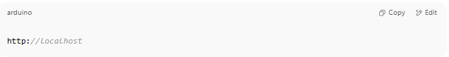
http://localhost

- You’ll see the XAMPP welcome page.

📁 Add your own files:
# Source: Chatgpt (GPT-5-Mini) at [1/16/2026]
- Go to:
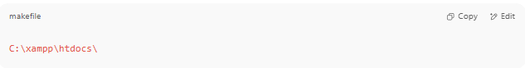
http://localhost

- Replace or add an index.html or index.php file.

🌐 Access from another device (optional):
# Source: Chatgpt (GPT-5-Mini) at [1/16/2026]
- Find your PC's IP (e.g., 192.168.1.5)
- On another device in the same network, go to:

http://192.168.1.5

✅ Summary
# Source: Chatgpt (GPT-5-Mini) at [1/16/2026]
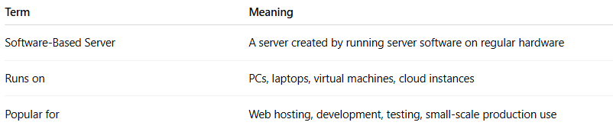
Term | Meaning
Software-Based Server | A server created by running server software on regular hardware
Runs on | PCs, laptops, virtual machines, cloud instances
Popular for | Web hosting, development, testing, small-scale production use

